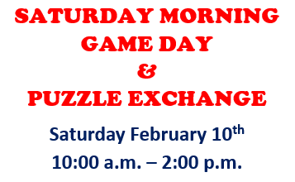 | Puzzle Exchange!   Exchange is simple! Bring a gently used (no missing pieces) puzzle of any size and trade it for one of similar size.  If you would like to donate a puzzle or drop one off earlier in the week you are welcome to do so. Donations will be gladly accepted and we can provide a voucher if you would like to return Saturday for a “NEW” puzzle!
Join us in the Library Activity Room for
Fun with Games & Puzzle Exchange!
Games scheduled include: Labyrinth,
A la Carte, NY Pizza Slice & Willy Wonka’s Golden Ticket!
Reservations for Games:
734-782-2430

